Survey Results for Fall 2012 - Spring 2013
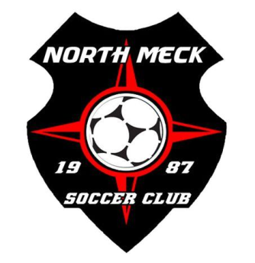
In an effort to serve the needs of our membership to the best of our ability we undertook a club wide survey to get your input on a wide variety of areas within our club. To follow you will find the results of that survey. All responses were reviewed individually by members of the Governance and Communications Committee and the Executive Director. We appreciate the fact that many of you not only took the time to complete the survey but offered great suggestions and comments. To date we have addressed or are in the process of taking action on many of those suggestions. Should you have any further questions after reading over the results, please feel free to contact Thomas at the club office to set up a time to speak. We’ve come a long way in the last several years and have a comprehensive plan on growing and improving at all levels of our organization. In the end we want North Meck Soccer Club to be known as THE place to play soccer in the area, regardless of the program or the level of play. With your ongoing help and input I am very confident that we can achieve just that! Thanks again for your time, your input and your ongoing support of North Meck Soccer Club.
Clubs Communication Philosophy
By seeking to provide the best possible soccer environment we focus towards the key aspects of facilities, coaching staff and service to our members. The communication and transparency of our programs, philosophy and service of the club are vital to our organizations operations and understanding for our members. Together we have developed the club’s culture, programs and overall service over the years. One aspect of this is by seeking direct communication from our members in the form of a survey at the end of each programs season. With an efficient and effective communication protocol along with an open door policy in all areas of the club for communication, we have been able to provide a better service to our members. The electronic survey completed last year by our members has allowed the club to quantify certain aspects of the programs for analysis in order to develop and nurture the service continuously.
Explanation of Feedback
We have categorized the feedback in several areas from programs to various aspects of the club in order to provide a good story book to the membership feedback. The feedback was received very well, analyzed and discussed as we prepared for this past fall season. Action was taken in certain areas and positive trends highlighted so as a club we make sure we continue to move in the right direction without sacrificing the philosophy of our programs.
The pie charts summarize the survey results across all divisions per survey category. As a next step the club is reviewing the detailed data to identify trends and improvement opportunities across each division. New this year the survey are analyzed with feedback between the fall and spring season. We hope you enjoy the findings below and please take the time to fill out the club survey when it's delivered via email next time around.
 |  |  |  | FALL 2012 |  |  |  |  |  |  |  |  |  | FALL 2013

